**B. Tech Project**

**Mid Sem Report**

On

**Utilization of Steel Slag on the performance of asphalt mixture**

By

Atul Baghel (220004014)

**Guided By**

**Dr. Priyansh Singh**



Department of Civil Engineering

## Indian Institute of Technology Indore

(2025-26)

**CANDIDATE’S DECLARATION**

We hereby declare that the project entitled “Utilization of Steel Slag on the performance of asphalt mixture” submitted in partial fulfillment for the award of the degree of Bachelor of Technology in ‘Civil engineering’ completed under the supervision of Dr. Priyansh Singh, Assistant Professor Civil Engineering , IIT Indore is an authentic work.

Further, I/we declare that I/we have not submitted this work for the award of any other degree elsewhere.

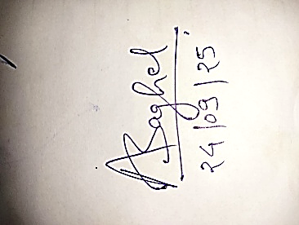 **Signature and name of the student(s) with date**

**_________________________________________________________________**

**CERTIFICATE by BTP Guide(s)**

It is certified that the above statement made by the students is correct to the best of my/our knowledge.

**Signature of BTP Guide(s) with dates and their designation**

**TABLE CONTENT**

|  |  |  |
| --- | --- | --- |
| Sno. | Particulars | Page No |
| 1. | **INTRODUCTION** | 5 |
| 1.1 | Background | 5 |
| 1.2 | Objective of study | 7 |
| 1.3 | Need of study | 7 |
| 1.4 | Problem definition | 7 |
| 1.6 | Limitations | 8 |
| 1.7 | Scope of work | 8 |
| 2. | **LITERATURE** | 9 |
| 3. | **MATERIAL AND METHODOLOGY** | 12 |
| 3.1 | Steel Slag | 12 |
| 3.1.1 | Physical and Mechanical Properties of Steel Slag | 12 |
| 3.1.2 | Chemical Composition of Steel Slag | 13 |
| 3.1.3 | Morphological Properties of steel slag | 14 |
| 3.1.4 | Properties of slag | 15 |
| 3.2 | Natural aggregates | 16 |
| 3.3 | Bitumen | 17 |
| 3.4 | Marshall Mix Design | 18 |
| 4. | Reference | 20 |

**List of Tables**

|  |  |  |  |
| --- | --- | --- | --- |
| Sno. | Table no. | Table Name | Page no. |
| 1. | Table 1 | Physical Properties Steel Slag Characteristics…. | 12 |
| 2. | Table 2 | Chemical Composition of Durgapur Steel Plant | 14 |
| 3. | Table 3 | Gradation of aggregate for Marshall mix design | 16 |
| 4. | Table 4 | Physical properties of VG (30) BITUMEN | 18 |

**List of Figures**

|  |  |  |  |
| --- | --- | --- | --- |
| Sno. | Figure no. | Fig Name | Page no. |
| 1. | Fig 1 | Production processing and uses of steelmaking slag | 6 |
| 2. | Fig 2 | Different Particle Size of Steel Slag | 13 |
| 3. | Fig 3 | Energy-dispersive X-ray (EDAX)  spectroscopy of 4.75 mm and 2.36mmsize | 14 |
| 4. | Fig 4 | SEM images Steel Slag | 15 |
| 5. | Fig 5 | Los Angeles Abrasion Test | 15 |
| 6. | Fig 6 | Impact Test | 16 |
| 7. | Fig 7 | Gradation of Aggregate | 17 |
| 8. | Fig 8 | Sample of Marshall mix design | 19 |

1. **INDRODUCTION:**
   1. **Background**

A significant environmental and resource management problem in recent decades has been the enormous volumes of steel slag generated by the global steel industry, mostly generated during smelting and refining operations (Díaz-Piloneta et al., 2021). Significant environmental risks include heavy metals leaking into soil and groundwater, widespread land occupation, and escalating conflicts between industry and ecology over land use, as less than 30% of the world's accumulated stockpiles—which total over 1.8 billion tons—are currently recycled (Annual Report 2023-24 , GOI ; Wang et al., 2021)

Around 2.3 billion tons of natural aggregates are utilized yearly for road building as a result of the transportation infrastructure's fast expansion, which puts a heavy strain on non-renewable resources and raises environmental issues (Wang et al., 2021). This trend contradicts the main sustainability goals set out in international programs like the Sustainable Development Goals of the United Nations, which demand carbon neutrality, resource circularity, and ecosystem restoration. In this regard, it becomes appropriate and pertinent to employ steel slag and other industrial wastes as alternative aggregates in road building.

India has the second-longest road network in the world and has started a massive highway expansion and upgrade program to allow for unrestricted freight and passenger movement within the nation at a reasonable cost. Every year, an enormous amount of natural aggregates is needed for the construction and upkeep of this extensive road system. A green field project requiring 60 to 70 thousand tons of natural aggregates is needed to build a one-kilometre six-lane road. Unsustainable rock mining and quarrying practices are meeting this demand, which is having detrimental effects on the environment, including desertification, the loss of forest cover and natural habitats, and topographical changes that pollute the air, water, and land.

Given an estimated 125 million tons of steel produced annually in 2022, India is the second-largest producer of steel in the world. Every year, 19 to 20 million tons of steel slag are produced nationwide through different steel plants, with 150 to 200 kg of steel slag being produced as solid waste for every tonne of crude steel produced.

After metal recovery, the majority of steel slag is disposed of as solid waste. When it comes to road construction, using steel slag as processed steel slag aggregates can be a good substitute for natural aggregates.

Although they use a lot of energy and could negate environmental benefits, high-temperature treatments encourage the crystalline transition of expansive minerals, increasing stability (Díaz-Piloneta et al., 2021) .Although their widespread application is limited by their environmental cost and complexity of implementation, surface coating and cement hydration treatments can also inhibit moisture-induced expansion.

Types of Steel Slag:

1. Basic Oxygen Furnace Steel Slag (BOF Slag)
2. Electric Arc Furnace Steel Slag (EAF Slag)
3. Converter Arcing Furnace Steel Slag (CONARC Slag)
4. Induction Furnace Steel Slag (IF Slag)

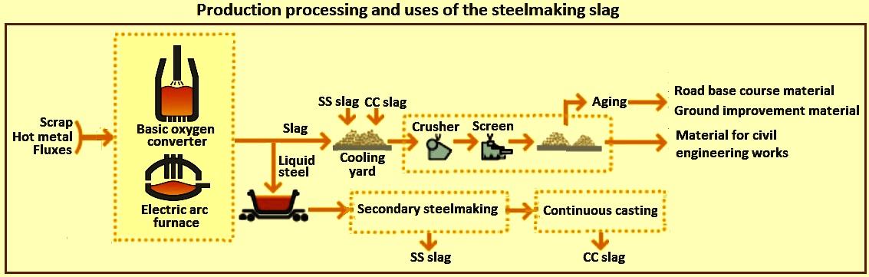

Fig 1 : Production processing and uses of steelmaking slag

Mineral carbonation is one of these novels, low-energy methods that sticks out. Free oxides are transformed into stable carbonates by reacting CO₂ with steel slag. These carbonates fill micropores and fissures and absorb a sizable portion of industrial carbon emissions Slag. (Eloneva et al., 2012). According to recent studies, carbonated steel slag enhances the mechanical and hydraulic qualities required for its use as a pavement material, as well volume stability.   
According to estimates, 4.7 tons of steel slag may sequester one ton of CO₂, producing 2.3 tons of CaCO₃. If this process were to be scaled up globally, it might save up to 9–10% of the greenhouse gas emissions from the iron and steel industry (Eloneva et al., 2012).

The carbonation process produced tufa-like materials on the surface of the BOF slag aggregate, which, when used as road base or sub-base, can hinder the drainage properties of the granular layers of the road. Steel slag carbonation reactions beneath the bituminous surface in unbounded pavement layers result in tufa precipitation.

Recent studies have extended the investigation to asphalt pavements, even though the majority of research to date has concentrated on carbonated steel slag as a cementitious ingredient. These studies employ advanced techniques like molecular dynamics simulations, scanning electron microscopy (SEM), and X-ray diffraction (XRD) to elucidate the microstructural mechanisms of asphalt–slag adhesion.(Díaz-Piloneta et al., 2021) .

These multiscale techniques link improvements in macroscopic performance, like Marshall stability, rutting resistance, and reduced water sensitivity, to nano-scale changes at the interface, offering a crucial theoretical foundation for expanding the use of steel slag in circular infrastructure systems.

* 1. **Objective of Study**

1. To determine the results , to use steel slag in asphalt mixtures in place of natural aggregates.
2. To find the mechanical and physical characteristics of steel slag.
3. To study potential treatment methods, particularly Carbonation, for improving the performance of steel slag.

**1.3 Need of Study**

Superior mechanical strength, a great affinity for asphalt, and a density comparable to natural aggregates are just a few of the benefits that steel slag offers. Due to these characteristics, it is a great option for use in high-traction areas, curves, and heavy-duty sections of road pavements (Díaz-Piloneta et al., 2021). Research indicates that replacing 15–30% of natural aggregates with steel slag lowers the need for raw materials and lessens the dangers of long-term storage of industrial waste (Wang et al., 2021). This collaboration promotes a circular economy at the industry level that connects the development of resilient infrastructure, ecological preservation, and the value-adding of metallurgical waste.

**1.4 Problem definition**

Even with these benefits, there are still difficulties. High levels of free calcium oxide (CaO) and magnesium oxide (MgO) are frequently found in steel slag. These substances react easily with water to generate expansion-prone products such calcium hydroxide (Chen et al., 2021; Díaz-Piloneta et al., 2021). Volumetric instability, a loss of cohesiveness at the asphalt-aggregate interface, and a shorter pavement lifespan are the results of this process. Furthermore, under humid or wet weather conditions, the porous structure of slag increases its potential to absorb water, intensifying hydration reactions and endangering long-term adhesion with asphalt (Sun & Wang, 2024).

**1.5 Limitations**

Temperature, humidity, particle size, reaction time, and CO2 concentration are some of the process factors that influence the carbonation reaction; to maximize efficiency and reduce expenses, these elements must be under control (Yadav & Mehra). Treatments like surface coating and high-temperature stabilization are expensive and energy-intensive, despite their effectiveness. There are currently few large-scale uses of carbonated steel slag in asphalt pavements, and more research is required to determine its long-term field performance.

**1.6 Scope of Work**

Steel slag, especially after carbonization, can be used in place of natural aggregates to reduce environmental effect and increase road pavement durability (Díaz-Piloneta et al., 2021; Sun & Wang, 2024) Steel slag's use as an aggregate in asphalt mixtures contributes to concrete engineering innovation in the quest for carbon neutrality and resource efficiency as industrialized nations work to reach next-decade climate and sustainability targets.

1. **LITERATURE REVIEW:**

Large-scale garbage removal and handling is costly and will undoubtedly have an effect on the environment. However, a portion of the waste or byproducts might be utilized for recycling, creating new goods, or as a building component. Since the steel and iron sector is one of the biggest waste disposal businesses, steelmakers benefit from the study and application of steel slag aggregates since it provides engineers with a high-performing raw material. Since steel slag aggregate is a by-product of the local steel industry, a proven product, and a high-quality material for use in the building sector, it should no longer be regarded as waste.

Steel slag was regarded as a waste product and was cast in massive stocks of over 4 million tons since Saudi Arabia's steel industry started in 1982. Beginning in 1994–1995, the SSA used a promotion mechanism in the construction industry.

A by-product of the steel production process, steel slag has a complicated chemical composition made up primarily of oxides and silicates that are created when different steel additives oxidize. The Electric Arc Furnace (EAF) process and the Basic Oxygen Furnace (BOF) process are the two main ways that steel is produced. Slag products, including copper slag, coal slag, blast furnace slag, and others, have found profitable use in cement manufacturing, abrasive manufacturing, and civil construction. According to (Zumrawi, n.d.) steel slag could be a viable substitute for aggregate for concrete when creating an asphalt mixture.

Uses of Steel assert that there is a dearth of research on the engineering characteristics of steel slag. Applications of civil engineering: Production of cement, Aggregate for concrete, aggregate for asphalt, Sub-bases and road bases, Stabilization of soil. Applications for other purposes: Steelmaking, Production of fertilizer, Waterway linings, Daily coverage for landfills, Ballast for railroads

Various environmental uses A certain percentage of steel slag is used for other purposes. For instance, a large amount of BOF slag is recycled during the steelmaking process by being charged directly into the blast furnace or basic furnace for oxygen. the impact of charging BOF slag into basic-oxygen and blast furnaces on the furnaces' performance and efficiency. Steel slag can also be used as a fertilizer for soil. Due to its high phosphorous concentration (P2O5>4%), steel slag (BOF slag, EAF slag, and ladle slag) has been utilized as a soil fertilizer. However, this use has recently been restricted due to the decline in the phosphorus level of contemporary steelmaking slag.

Coarse steel slag aggregate has also been utilized in Europe as railroad ballast and as a waterway liner in road building (Fronek et al., 2012) .A small portion of the surplus steel slag in the United States is utilized to build landfill covers on a regular basis. Steel slag's primary uses in civil engineering can be categorized into three main areas:

1) The cement and concrete industry;

2) Road construction;

3) Geotechnical applications, which include soil stabilization and embankment building.

The following sections provide a quick summary of the reported studies on various applications.

In the base course of roads, steel slag has been utilized with success. In particular, steel slag is successfully used as an aggregate for coating and base pavement flexible in Europe, Canada, Australia, and the USA, where it is not seen as industrial waste but rather as a valuable building material. 17 businesses in 29 US states produce steel slag. Both steel (BOF or EAF) slag is the preferred material, according to special specifications, a sufficient record of its applications, and performance on significant projects worldwide.

One of the benefits of employing steel slag asphalt concrete in Batlimore., is its strong skid resistance, which is offered throughout the duration of the pavement's life in both wet and dry situations. Between test sections 1979 and 1981, SSA and asphalt mixtures were utilized to create a surface layer that was 1 to 1.25 inches thick on some Indiana highways. Six distinct combinations of coarse and fine aggregate were used to create asphalt, resulting in mixtures with a broad variety of grades and amounts of steel slag coarse aggregate.

According to surveys, steel slag from road surfaces has long-term skid resistance qualities that are at least as excellent as those of similar road surfaces made of natural aggregates under comparable traffic situations. In nations with high ambient temperatures, which seriously impair asphalt surfaces, Steel Slag Aggregate (SSA) has also been utilized with success. Singapore, Malaysia, Australia, South Africa, Saudi Arabia, and Italy are only a few of the warm-weather nations that have already attained the outstanding qualities of steel slag asphalt.

In applications involving Hot Mix Asphalt (HMA) surface mixtures, steel slag has become the perfect aggregate. Steel slag's characteristics make it a top surface aggregate for skid-resistant applications, where friction is a crucial safety factor in pavement design for the general public that drive. Steel slag has established itself as a premium surface aggregate with the advancement and use of super pave technology across the US and the continued growth of Stone Matrix Asphalt (SMA) mixes for high traffic and axle-loading applications. In addition, steel slag is still widely used in seal coating and cold patching applications.   
Steel slag coarse aggregate SMA pavement, which is renowned for its durability and resilience, was used to create the new surface of the Indianapolis Motor Speedway in 2005. They choose steel slag, like DOT and many other users, due to its remarkable friction qualities, durability, and long lifespan. The horizontal shear loads caused by cars speeding into the curves at 200 miles per hour are too great for any regular pavement. However, steel slag can, which is why the track officials decided to use it as the pavement's coarse material.

In a similar vein, Colorado state transportation officials selected steel slag coarse aggregate to replace the picturesque I-70 through Glenwood Canyon because they desired a pavement that would be stable, long-lasting, and high-friction. Truck traffic hammering and straining the I-70 corridor can be accommodated by the lengthy ascent and descent over the mountains encircling Glenwood Canyon. Outside the biggest stone quarry in Illinois, which is close to Chicago, only steel slag SMA pavement can sustain the truck traffic. The steel slag SMA pavement at the intersection of Williams and Margaret Streets was named the strongest intersection in the world by the Asphalt Institute. Steel slag is a sustainable, renewable, recycled aggregate that should be used the next time you pick asphalt pavement for your driveway, parking lot, parking area, or access road.

**3. MATERIAL AND METHODOLOGY:**

**3.1 Steel Slag**

Steel Slag is regarded as industrial waste and is created as a byproduct of the steelmaking process. The production of steel generates a substantial amount of waste, typically between two and four tons, which is made up of solids, liquids, and gases. When scrap is melted to create steel in an electric arc furnace (EAF) or electric induction furnace, or when iron is converted to steel using a basic oxygen furnace (BOF), steel slag is a byproduct.

**3.1.1 Physical Properties of Slag:**

Instead of evaluating the cementitious qualities of steel slag, the majority of research in the literature concentrates on its chemical properties and mineralogy. Research in this field is obviously needed, as evidenced by the lack of study of the geotechnical features of steel slag, such as its compaction characteristics and shear strength parameters. The Steel slag used in these experiments was provided by Durgapur steel plant which is integrated steel production facility in West Bengal, India.

A substance's specific gravity is a measure of how heavy or light it is in relation to a standard material. Particles having more specific gravity are more stable and stronger. The behavior of a soil mass under external loads cannot be inferred from specific gravity alone. Hydrometer analysis and soil mineral classification both benefit from specific gravity. For calculating the hydraulic gradient, it is helpful. It may be better to use kerosene instead of distilled water for soils that contain soluble salts. Water content of slag is found by oven dry method. In this method slag sample is oven dried at 105 °C to 110 °C for twenty-four hours. IS-2386 part5.

Table 1: Physical properties Steel Slag Characteristics

|  |  |  |  |  |
| --- | --- | --- | --- | --- |
| S. no. | | Characteristics | Coarse Steel Slag (9.5-4.5mm) | Fine Steel Slag (4.75-2.36mm) |
| 1. | Bulk Specific gravity | | 2.35 | 2.38 |
| 2. | Apparent Specific gravity | | 2.54 | 2.64 |
| 3. | Water absorption | | 3.24% | 4.26% |

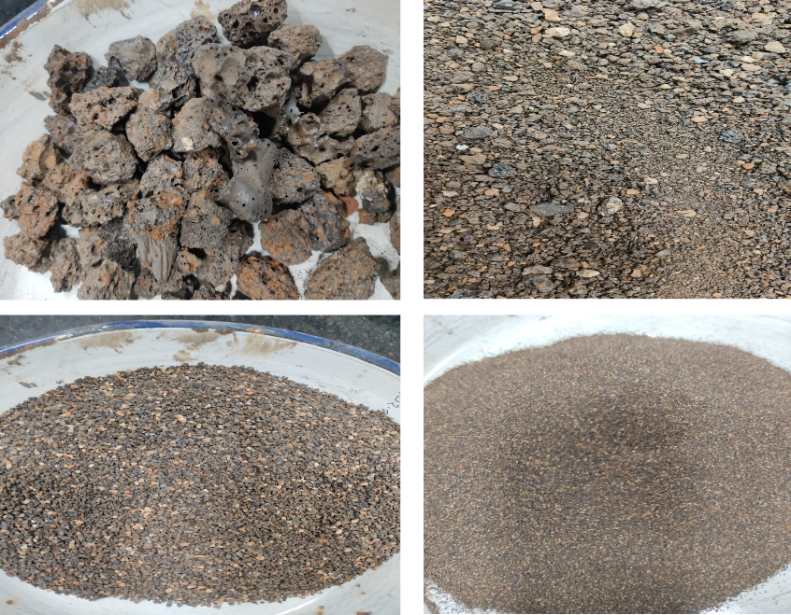

Fig 2: Different particle size of steel slag

**3.1.2 Chemical Composition of Steel Slag**

Chemical components of steel slag is crucial for determining its suitability for use into asphalt mixes. Aggregates' density, durability, and adhesion to binder are all determined by their chemical composition. The use of Basic Oxygen Furnace Slag (BOFS) in asphalt mixtures may be restricted by the higher concentration of free lime in BOFS compared to Electric Arc Furnace Slag (EAFS). (Yildirim & Prezzi, 2011).Table displays the chemical components found in steel slag. The alkaline properties of steel slag enhance its ability to adhere to bitumen, which is acidic in nature. This ensures a stronger bond between steel slag and bitumen in asphalt mixes ((Aziz et al., 2014; Ye et al., 2019) . Steel slag is appropriate for use as a pavement material because of its chemical properties and toxicity levels, which are below allowable limits. (Asi et al., 2007) .The primary chemical components of slags include calcium oxide (CaO), magnesia (MgO), silicon dioxide (SiO2), and iron oxide (FeO).

Energy Dispersive X-Ray Analysis (EDAX), also known as EDS or EDX is an analytical technique coupled with scanning electron microscopy (SEM) that identifies and quantifies the elemental composition of material. When a specimen is bombarded with an electron beam, it emits characteristics X-Rays corresponding to the energy levels of the elements present. By detecting and analysing these X-Rays, Edax provides both qualitative and semi-qualitative data an elemental composition.

The chemical composition of steel slag which was obtained from the Durgapur Steel Plant was analysed using Energy Dispersive X-Ray Analysis (EDAX). The results revealed that the slag samples contain a sufficient amount of iron (Fe), calcium (Ca), oxygen(O) and aluminium (Al) . As we can see from Fig3 and Table 2 that, the composition varies with particle size 2.36mm fraction shows higher oxygen and silicon content, while the 9.5mm fraction is richer in iron (42.94%) and calcium (6.50%), whereas 4.75mm exhibits the highest aluminium 19.6% and calcium 7.13 content, which suggests diversity in slag chemistry depending on particle size distribution. Such variations are crucial because that influence the mechanical, chemical and durability characteristics of slag.

Table 2: Chemical Composition of Durgapur Steel Plant

|  |  |  |  |  |
| --- | --- | --- | --- | --- |
| Sno. | Name of Element | Sample size of Steel Slag | | |
| 2.36mm | 4.75mm | 9.5mm |
| 1. | Ca | 4.22 | 7.13 | 6.50 |
| 2. | Mg | 0.45 | 3.13 | 1.28 |
| 3. | O | 39. | 26.3 | 35.07 |
| 4. | Fe | 38 | 33 | 42.94 |
| 5. | Al | 7.21 | 19.6 | 6.24 |
| 6. | Si | 10.5 | 10.1 | 7.99 |

Fig 3: Energy-dispersive X-ray (EDAX) Spectroscopy of 4.75 mm and 2.36mm size

**3.1.3 Morphological Properties of steel slag**

The configuration and appearance of the aggregates significantly affect the mechanical properties and moisture susceptibility of asphalt mixes. Particle interlocking has an impact on rutting, which is also connected to aggregate morphologies and angularity. High stiffness and rutting resistance are the results of the asphalt mixture's strong interlocking effect caused by the angular shape of the fine aggregate.(Chen et al., 2021) In their study (Ali Jattak et al., 2019) used a FESEM to analyze the physical properties of granite and steel slag. They found that steel slag's surface was more angular, rough, and porosity-rich than granite aggregates. As a result, the asphalt mixture required a higher optimal bitumen content. When compared to natural aggregate, steel slag has better mechanical and physical properties because of its higher bulk specific gravity.

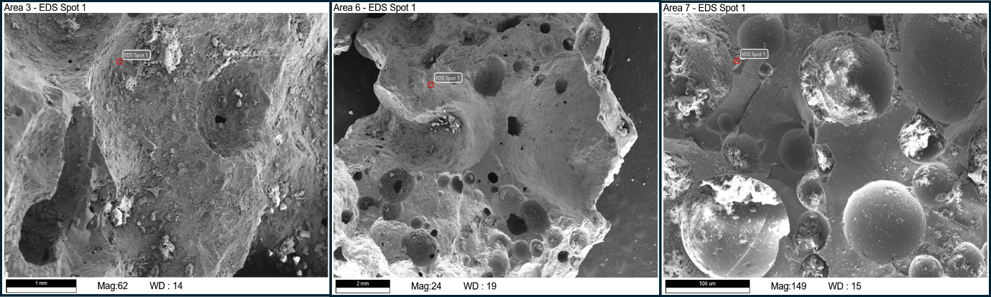

Fig 4: SEM images of Steel Slag

**3.1.4 Properties of Slag**

**Abrasion value of steel slag: -**

The abrasion value of aggregates for wearing surfaces should not be more than 30% by weight. The aggregate abrasion value should not exceed 50% by weight of aggregates for concrete used in non-wearing surfaces, as per IS: 2386 (Part IV). Steel slab used which was 4.75-2.36 mm. The first sample (Durgapur Steel Plant) Percentage of wear: in average is 46 %. The abrasion value of slag is good as per IS specifications thus we can use this steel slag for the construction base layer in road.

Fig 5: Los Angeles Abrasion Test

**Impact value of Steel slag: -**

The aggregate impact value should be less than 30 % by weight for concrete wearing surface i.e runways, roads, pavements, floors etc. IS: 383-1970, IS: 2386 (Part-4). After the impact value test the average impact value of steel slag is 29.51% the slag, which has enough strength for impact loading as the value lies in between the IS specified limit.

Fig 6: Impact Test

* 1. **Gradation of Aggregates:**

The study's aggregates came from a nearby quarry and were assessed for acceptability in asphalt concrete mixtures using Indian Standards (IS: 2386).Various sizes of aggregates were systematically separated by standard sieve. Thegradation process helps quantify the distribution of particles present. Aggregates' physical characteristics met all necessary requirements to be used in bituminous concrete. The physical properties of the aggregates used is given in Table No 3.

Table 3: Gradation of aggregate for Marshall mix design (MoRTH)

|  |  |
| --- | --- |
| Grading | BC - 2 |
| Nominal aggregate size | 13.2mm |
| Layer thickness | 30-40mm |
| Is Sieve (mm) | Cumulative % by eight of total aggregate passing |
| 19 | 100 |
| 13.2 | 90-100 |
| 9.5 | 70-88 |
| 4.75 | 53-71 |
| 2.36 | 42-58 |
| 1.18 | 34-48 |
| 0.6 | 26-38 |
| 0.3 | 18-28 |
| 0.15 | 12-20 |
| 0.075 | 4-10 |
| Bitumen content % by mass of total mix | Min 5.4 |

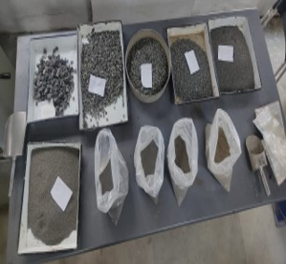

Fig 7: Gradation of Aggregate

**3.3 BITUMEN**

Because of its balanced viscosity and high-temperature performance qualities, VG30 grade bitumen is a popular paving binder in India, especially for building heavy-duty flexible pavements. It is made to handle heavy traffic loads in warm climates and is categorized under the viscosity grading system, which is thought to be more basic than the previous penetration-based method (Venkat Ramayya et al., 2016).According to studies, VG30 bitumen can be successfully altered with additives to increase its resistance to rutting, short-term aging, and temperature susceptibility, improving the performance and longevity of pavements. The bitumen used in the study is Viscosity Grade-30 (VG-30), which is provided by Tiki Tar Industries in the Halol Vadodara area.

Table 4: Physical properties of VG (30) BITUMEN

|  |  |  |  |  |
| --- | --- | --- | --- | --- |
| S.No | Property | Paving Grade  (Vg 30) | Result | Method Of Test(Is-Code) |
| 1. | Ductility | 40(min) | 100(cm) | IS 1208 |
| 2. | Penetration | 45(min) | 6.7mm | IS 1203 |
| 3. | Viscosity֯(135°C) | 350(min) | 692mpa.S | IS 1206 (Part 3) |
| 4. | Softening Point | 47°C(min) | 53.2°C | IS 1205 |
| 5. | Flash And fire | 220°C(min) | 265°C | IS 1448 |
| 6. | Solubility | 99%(min) | >99.0% | IS 1216 |
| 7. | Specific Gravity | 1.02 | 1.01 | IS 1202 |

* 1. **Marshall Mix Design**

Three types of each HMA mixtures will be produced with five different asphalt concentrations of 5 , 5.5, 6 , 6.5 and 7% by weight of the total aggregates, in accordance with (MoRTH). First sample as shown in fig 8 , a control mix (CM) with 100% natural aggregate was produced. Further, steel slag incorporated HMA mixes will be prepared, respectively, by replacing 30% of the CNA that passes through a sieve size of 19 mm and is retained on pan. The specifications of each HMA mixture are represented in Table 3. The graded aggregates weighing 1.2 kilograms will be heated in an oven for 24 hours at 150–170°C, aggregates and asphalt would be mixed properly at 150–165°C until they coat uniformly. The heated asphalt mixture will be then put into the Marshall mold and compacted by automatic Marshall compactor with 75 compaction blows on each side to generate three specimens for each asphalt content. After that their dimensions, specific gravity, and other volumetric parameters, namely air voids (Va), voids in mineral aggregates (VMA), and asphalt-filled voids (VFA), will be measured following the guidelines provided by the (Standard, 2019). The test set up for Marshall stability and flow value test. Before being loaded into the Marshall stability machine to evaluate their Marshall stability and flow value, the HMA specimens were submerged in a 60°C water bath for 30 minutes.

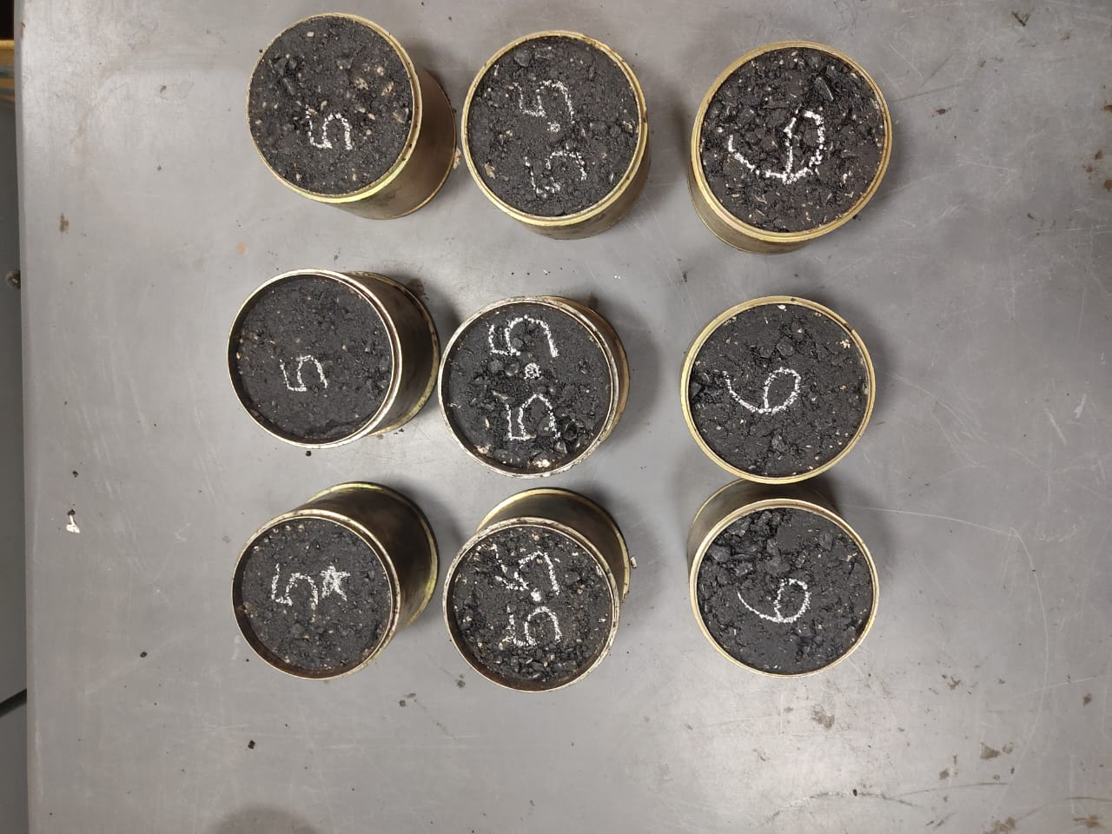

Fig 8: Samples of Marshall mix design

**REFERENCES: -**

1. Díaz-Piloneta, M., Terrados-Cristos, M., Álvarez-Cabal, J. V., Vergara-González, E. (2021). Comprehensive Analysis of Steel Slag as Aggregate for Road Construction: Experimental Testing and Environmental Impact Assessment. *Materials (Basel)*, 14(13):3587.
2. Sun, Y., Wang, J. (2024). Accelerated Carbonation of Steel Slag and Their Valorisation.
3. Chen Z.Cang Z.Yang F.Zhang J.Zhang L.(2021a). Carbonation of Steelmaking Slag Presents an Opportunity for Carbon Neutral: A Review. *J. CO2 Util.*54, 101738. 10.1016/j.jcou.2021.101738
4. Zhang F.Wang D.Cannone Falchetto A.Cao Y.(2024). Microwave Deicing Properties and Carbon Emissions Assessment of Asphalt Mixtures Containing Steel Slag Towards Resource Conservation and Waste Reuse. Sci. Total Environ.912, 169189. 10.1016/j.scitotenv.2023.169189
5. Azadi M.Edraki M.Farhang F.Ahn J.(2019). Opportunities for Mineral Carbonation in Australia’s Mining Industry. Sustainability11, 1250. 10.3390/su11051250
6. Eloneva S.Said A.Fogelholm C.-J.Zevenhoven R.(2012). Preliminary Assessment of a Method Utilizing Carbon Dioxide and Steelmaking Slags to Produce Precipitated Calcium Carbonate. *Appl. Energy*90, 329–334. 10.1016/j.apenergy.2011.05.045Pan, J., et al. (2014, 2017, 2020). Carbon mineralization with industrial wastes.
7. Mei X.Zhao Q.Min Y.Liu C.Saxén H.Zevenhoven R.(2022). Phase Transition and Dissolution Behavior of Ca/Mg-Bearing Silicates of Steel Slag in Acidic Solutions for Integration With Carbon Sequestration. *Process Saf. Environ. Prot.*159, 221–231. 10.1016/j.psep.2021.12.062
8. Wang J.Zhong M.Wu P.Wen S.Huang L.Ning P.(2021c). A Review of the Application of Steel Slag in CO2 Fixation. *ChemBioEng Rev.*8, 189–199. 10.1002/cben.202000021
9. Yadav S.Mehra A.(2021). A Review on *Ex Situ* Mineral Carbonation. *Environ. Sci. Pollut. Res.*28, 12202–12231. 10.1007/s11356-020-12049-4
10. Ministry of India (2023). Steel slag production statistics. *Frontiers in Soil Science*
11. Magdi M. E. Zumrawi, Faiza O. A. Khalill, “Experimental Study of Steel Slag Used as Aggregate in Asphalt Mixture”, International Scholarly and Scientific Research & Innovation 9(6) 2015 scholar.waset.org/1999.3/10002247
12. Irem Zeynep Yildirim, Monica Prezzi “Use of Steel Slag in Subgrade Applications” FHWA/IN/JTRP-2009/32, SPR-3129, 10/09 JTRP-2009/32 INDOT Office of Research and Development West Lafayette, IN 47906
13. Khan, Z.A., Malkawi, R.H., Al-Ofi, K.A., Khan, N. 2002. Review of Steel Slag Utilization in Saudi Arabia. 6th Saudi Engineering Conference. KFUPM, Dhahran, Saudi Arabia
14. Irem Zeynep Yildirim and Monica Prezzi. Chemical, Mineralogical, and Morphological Properties of Steel Slag. Advances in Civil Engineering, 2011:1–13, 2011. ISSN 1687-8086.
15. Aziz, M. M. A., Hainin, M. R., Yaacob, H., Ali, Z., Chang, F. L., & Adnan, A. M. (2014). Characterisation and utilisation of steel slag for the construction of roads and highways. Materials Research Innovations, 18(sup6), S6-255.
16. Noureldin A.S., McDaniel R.S. (1990) Evaluation of surface mixtures of steel slag and asphalt, Transportation Research Record, 1269(1269), 133-149.
17. Taha, R., Sirin, O., & Sadek, H. (2014). Recycling of Local Qatar’s Steel Slag and Gravel Deposits in Road Construction.
18. Asi, I. M., Qasrawi, H. Y., & Shalabi, F. I. (2007). Use of steel slag aggregate in asphalt concrete mixes. Canadian Journal of Civil Engineering, 34(8), 902-911
19. Adegoloye, G., Beaucour, A. L., Ortola, S., & Noumowé, A. (2015). Concretes made of EAF slag and AOD slag aggregates from stainless steel process: mechanical properties and durability. Construction and Building Materials, 76, 313-321.
20. Hesami, S., Ameri, M., Goli, H., & Akbari, A. (2015). Laboratory investigation of moisture susceptibility of warm-mix asphalt mixtures containing steel slag aggregates. International Journal of Pavement Engineering, 16(8), 745-759.
21. Jattak, Z. A., Hassan, N. A., Shukry, N. A. M., Satar, M. K. I. M., Warid, M. N. M., Nor, H.
22. M., & Yunus, N. Z. M. (2019, January). Characterization of industrial by-products
23. as asphalt paving material. In IOP Conference Series: Earth and Environmental
24. Science (Vol. 220, No. 1, p. 012012). IOP Publishing.
25. Lim, J. S., Cheah, C. B., & Ramli, M. B. (2019). The setting behavior, mechanical properties and drying shrinkage of ternary blended concrete containing granite quarry dust and processed steel slag aggregate. Construction and Building Materials, 215, 447-461.
26. Manso, J. M., Polanco, J. A., Losanez, M., & Gonzalez, J. J. (2006). Durability of concrete made with EAF slag as aggregate. Cement and concrete composites, 28(6), 528- 534.
27. Wang, G., Wang, Y., & Gao, Z. (2010). Use of steel slag as a granular material: volume expansion prediction and usability criteria. Journal of Hazardous Materials, 184(1- 3), 555-560.
28. Ye, Y., Wu, S., Li, C., Kong, D., & Shu, B. (2019). Morphological Discrepancy of Various Basic Oxygen Furnace Steel Slags and Road Performance of Corresponding Asphalt Mixtures. Materials, 12(14), 2322
29. Yildirim, I. Z., & Prezzi, M. (2011). Chemical, mineralogical, and morphological properties of steel slag. Adv Civ Eng.
30. Fig 1: <https://www.ispatguru.com/steel-making-slag/1000/>